**Chapter 3 : File system Internals**

* 1. **- Write the program to show file statistics using the stat system call. Take the filename / directory name from user including path.**

**Objectives :**

* + 1. To learn about File system Internals.

**Theory :**

Name:

stat, fstat, lstat - get file status

Syntax:

#include <sys/types.h> #include <sys/stat.h> #include <unistd.h>

int stat(const char \**path*, struct stat \**buf*); int fstat(int *fd*, struct stat \**buf*);

int lstat(const char \**path*, struct stat \**buf*);

Description:

These functions return information about a file. No permissions are required on the file itself, but-in the case of stat() and lstat() - execute (search) permission is required on all of the directories in *path* that lead to the file.

stat() stats the file pointed to by *path* and fills in *buf*.

lstat() is identical to stat(), except that if *path* is a symbolic link, then the link itself is stat-ed, not the file that it refers to.

fstat() is identical to stat(), except that the file to be stat-ed is specified by the file descriptor *fd*.

All of these system calls return a *stat* structure, which contains the following fields : struct stat {

dev_t st_dev; /* ID of device containing file */ ino_t st_ino; /* inode number */

mode_t st_mode; /* protection */ nlink_t st_nlink; /* number of hard links */

|  |  |  |
| --- | --- | --- |
| uid_t | st_uid;  st_gid; | /* user ID of owner */ gid_t  /* group ID of owner */ |
| dev_t | st_rdev; | /* device ID (if special file) */ |
| off_t | st_size; | /* total size, in bytes */ |

blksize_t st_blksize; /* blocksize for file system I/O */ blkcnt_t st_blocks; /* number of 512B blocks allocated */ time_t st_atime; /* time of last access */

time_t st_mtime; /* time of last modification */ time_t st_ctime; /* time of last status change */

};

**Data Dictionary :**

|  |  |  |  |
| --- | --- | --- | --- |
| Sr Number | Variable/Function | Datatype | Use |
| 1 | fileStat | struct stat | Store information about files. |

**Flowchart :**

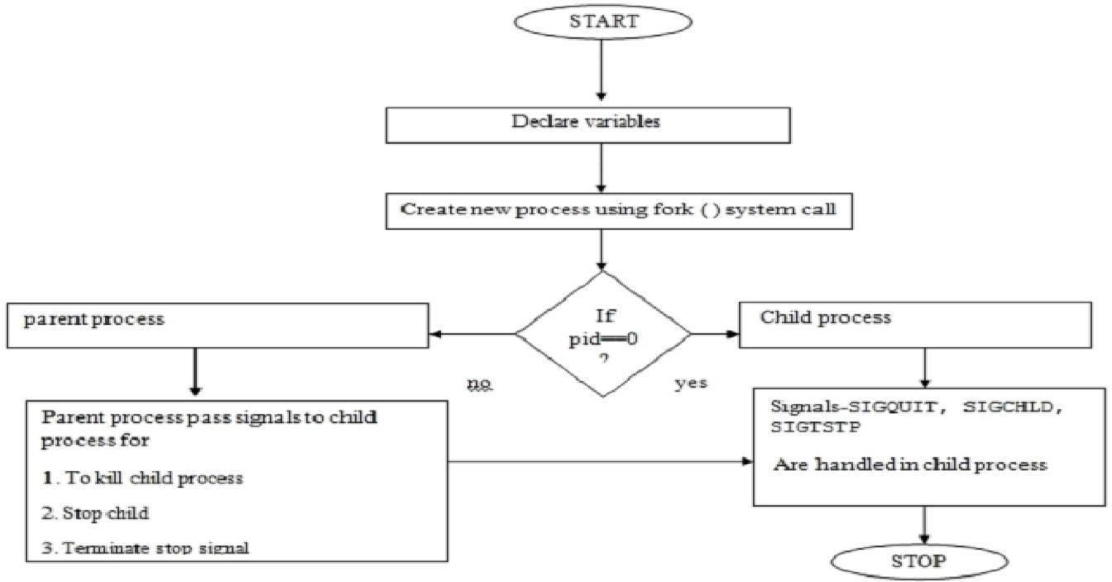

Fig: 3.1 Flowchart

**Program :**

**#include <stdio.h>**

#include <stdlib.h>

#include <sys/types.h>

#include <sys/stat.h>

#include <unistd.h>

int main() {

char path[100];

printf("Enter the file or directory path: ");

fgets(path, sizeof(path), stdin);

// Remove the newline character from the input

if (path[strlen(path) - 1] == '\n') {

path[strlen(path) - 1] = '\0';

}

struct stat fileStat;

// Use the stat system call to retrieve file statistics

if (stat(path, &fileStat) == -1) {

perror("Error: Unable to retrieve file statistics");

exit(EXIT_FAILURE);

}

printf("File Statistics:\n");

printf("Path: %s\n", path);

printf("Size: %ld bytes\n", fileStat.st_size);

printf("Owner ID: %u\n", fileStat.st_uid);

printf("Group ID: %u\n", fileStat.st_gid);

printf("File Permissions: %o\n", fileStat.st_mode);

return 0;

}

**Output :**

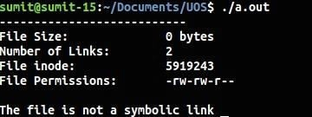

**Conclusion :**

* Stats of file like file size,links, permissions, inode number and type of link can be retrieved using stat() and stored in a structure.

**References :**

[1]https:/[/www.lix.polyt](http://www.lix.polytechnique.fr/~liberti/public/computing/prog/c/C/FUNCTIONS/stat.h)e[chnique.fr/~liberti/public/computing/prog/c/C/FUNCTIONS/stat.h](http://www.lix.polytechnique.fr/~liberti/public/computing/prog/c/C/FUNCTIONS/stat.h)